**Design Template**

|  |
| --- |
| American Video Game Company |
| CRM System Design Proposal |
| Business Vision Document/Business Requirements |

|  |
| --- |
| 8-6-2020  [Version 1.1] |

Contents

A. Introduction 3

A.1. PUrpose Statement 3

A.2. Overview of THE PROBLEM 3

A.3. Goals and Objectives 3

A.4. Prerequisites 3

A.5. Scope 3

A.6. Environment 4

B. Requirements 5

B.1. Business Requirements 5

B.2. User Requirements 5

B.3. Functional Requirements 14

B.4. NonFunctional Requirements 17

C. SOFTWARE DEVELOPMENT METHODOLOGY 18

C.1. Advantages of the waterfall method 18

C.2. disAdvantages of the waterfall method 19

C.3. best SUITED 19

D. Design 20

D.1. Flowchart 20

D.2. UML Diagram 21

D.3. GUI (Change title to fit needs) 22

E. Testing 23

E.1. User Interfacce testing 23

E.1.1. Test Name 1 23

E.1.2. Hard Delete Test 24

E.1.3. User activity logging 25

# Introduction

American Video Game Company needs a new customer relationship management (CRM) system to maintain their current growth. In the sections below we describe the sale’s force needs, outline the objective and goals for the new tool, propose the architecture of the tool and explain the testing plan to be put forth.

# A.1. PUrpose Statement

The purpose of the document is our proposed recommendation for a CRM solution to meet the needs of American Video Game Company’s needs for its sales force.

# A.2. Overview of THE PROBLEM

The sales force needs a new tool solution to keep up with the growth and to better track the company’s sales. American Video Games Company’s sales for the past 2 years have been up by 42% and is currently outgrowing its current CRM systems. The new CRM solution will provide American Video Game Company to manage reporting, perform activity management, track sales and opportunities, and manage client contract. The new CRM solution will allow the company to forecast future sales and growth based on historical data.

# A.3. Goals and Objectives

We will build a new CRM system which will reflect existing business processes as much as possible. This will be achieved by allowing users to archive information, maintain version records, implementing auditing, implement the ability to roll-back, manage workflows, and additional featured listed below. The CRM system will be hosted in our cloud server farm as well as the backend databases. Both internal and third-party vendors that need access to the CRM system will access it by visiting http://crm.american-videogames.com.

# A.4. Prerequisites

All prerequisites that need to be in place or implemented prior to the design, development and implementation of the proposed project are outlined throughout the document.

|  |  |  |  |
| --- | --- | --- | --- |
| Number | Prerequisite | Description | Completion Date |
| 1 | N/A | Workflow defined with clear success criteria. | 9/11/2020 |
| 2 | 1 | Requirements defined in this document that have been approved by the leadership stakeholders. | 9/18/2020 |
| 3 | 1, 2 | Budget approval and appropriated to the project | 9/30/2020 |

# A.5. Scope

This proposal document describes and explains the business and user requirements both functional and non-functional. We describe the environment, software compatibility, technical details, and the software solution and the architecture behind supporting the CRM solution. Lastly, we provide a testing plan to validate the CRM software solution.

For cost savings the solution will not include the following but will remain secure and only accessible to American Video Game Company’s employees and clients. The solution will not be hosted on dedicated servers in the cloud only provisioned to American, the environment will be hosted in a shared cloud environment in our offices to reduce cost passed on to American. The solution will also not be compatible with any system that does not meet the requirements stated below in the environment requirements.

# A.6. Environment

The proposed CRM solution will be compatible with current desktop hardware deployed within the company and cross compatible to current web browsers on the market and deployed on company assets.

Supported Web Browsers

* Chrome and Chromium (latest version)
* Firefox (latest version)
* Internet Explorer 10 or higher
* Safari 5.1 or higher
* Opera Browser (latest version)

Mobile and Tablet Browsers

* iOS 10 Safari
* iOS Chrome or Firefox (latest version)
* Android 9.0 or higher Chrome (latest version)
* Android 9.0 or higher Firefox (latest version)

American Video Games Company currently has an active directory server which must be integrated into the CRM.

The CRM will be hosted within our current cloud-based server farm which will host the webpages and backend databases. Individual workstations and mobile devices will be used to access the new tool from current supported web browsers.

# Requirements

With American Video Game Company sales up 42% for the past two years they need a new CRM tool to keep up with the growth. With the company currently out growing their existing solutionthe new solution will provide American Video Game Company a new tool to allow for growth and give them the following abilities: manage reporting and related sales activities, track sales and opportunities, and manage client contacts and contracts. All aspects will be in accordance the following detailed requirements. To meet the requirements of American Video Game Company, we will build a custom bespoke CRM that meets each of the requirements specified to meet their specific needs.

# Business Requirements

The are 2,000 users that will access the system with an expected 500 concurrent users during peak times. The system must be able to scale up to reasonable levels of growth beyond the provided user counts.

The proposed solution will do the following:

1. Consolidate client and customer contact information along with all other business relevant information
2. Report and manage all interactions with contacts and related activities
3. Role-based access control will the utilized to control both internal and third-party access to the CRM
4. Permissions management
5. Enable access to 3rd party marketing contractors
6. Management of sales reporting and sales tracking
7. CRM will integrate with current internal company systems for data sharing
8. Allow for ease of use, scalability and be secure
9. Reasonable cost enhancement abilities with a known maintenance and support structure
10. Clear roadmap for future enhancements, updates, and upgrades
11. Defined ownership rights and clear licensing model
12. Integrate with the companies current internal hosting intrastate or have illustrated good reason to not integrate
13. Compliance with all relevant laws, regulations, and industry best practices
14. All data stored within US datacenter with restrictions on exportation unless prior approval is obtained

# User Requirements

The CRM will need to perform specific tasks that include contact management, ticket creation and closure, both reporting generation and management, management of sales’ visit and meeting activities, opportunity tracking and management, generation of quotes and quote archiving, contract and order management. Some of the previous requirements are duplicated the following sections.

For contract management Sales has generated the following requirements:

All users need to be categorized by either business or end-user, each will have a different T&C, their own preferred contact method, and how their details may be used (e.g. businesses may want to be a strategic partner which allows for their logo to be used in American Video Game Company’s advertising) The CRM will have check boxes, text entry boxes and areas to attach addition supporting documentation to support these defined needs.

Users will need to self-serve; this allows them to set their own contact and marketing preferences and preferred contact method (e.g. phone number or email). This can be completed either by signing into their online account or when contacting American Video Game Company team member directly.

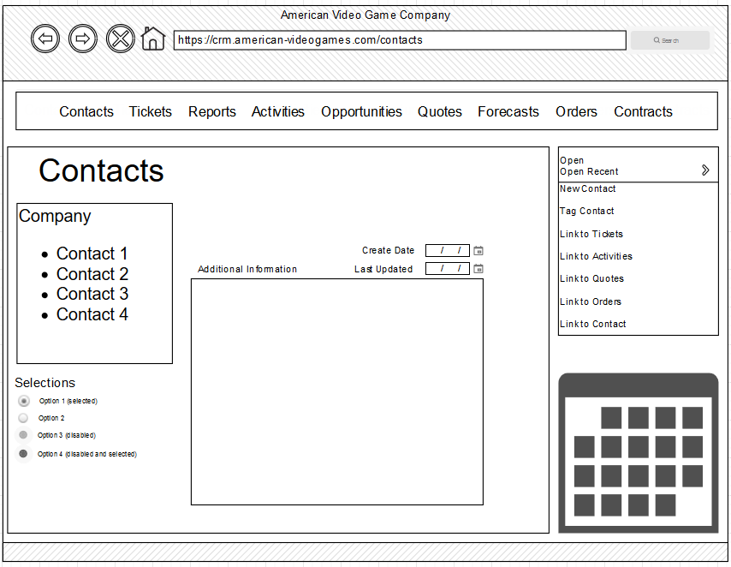

For ticketing the Sales team has the following requirements:

On a per contact basis, the ticketing system will retain contact information allowing the sales team to enter and track all communications and inquiries. The ticket will include fields for who called, reason for call, date and time stamps, follow-up data and relevant details of the call. Emails and email replies will be detected by the system and tracked on a per contact basis.

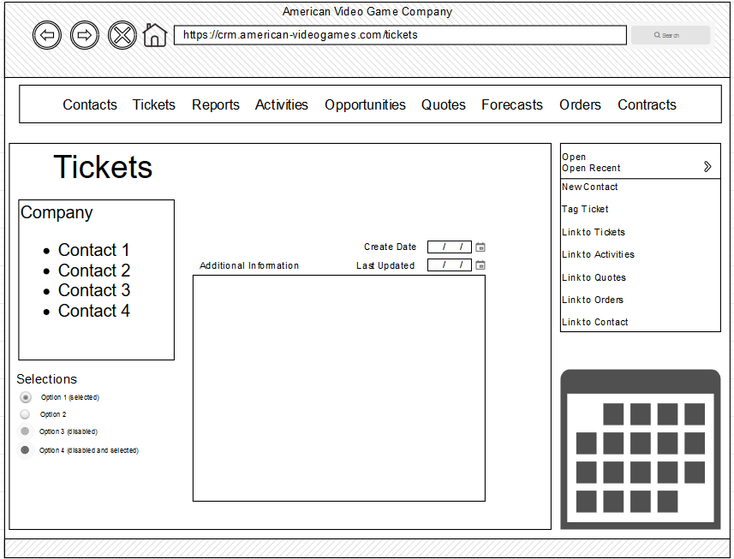

For reporting the Sales team has the following requirements:

The CRM system will support and deliver predefined and user created reports allowing the use of all data held in the database. The user interface should be easy to use and navigate, allow for filtering, formatting, support for querying, exporting of data. The reporting tool should also allow for both detailed and not so granular reporting. Dashboard creation, historical data reports and templates for executive level summaries need to be available. Users should be able to click through data in the UI, save it or save and reuse and filter they have applied for future reports.

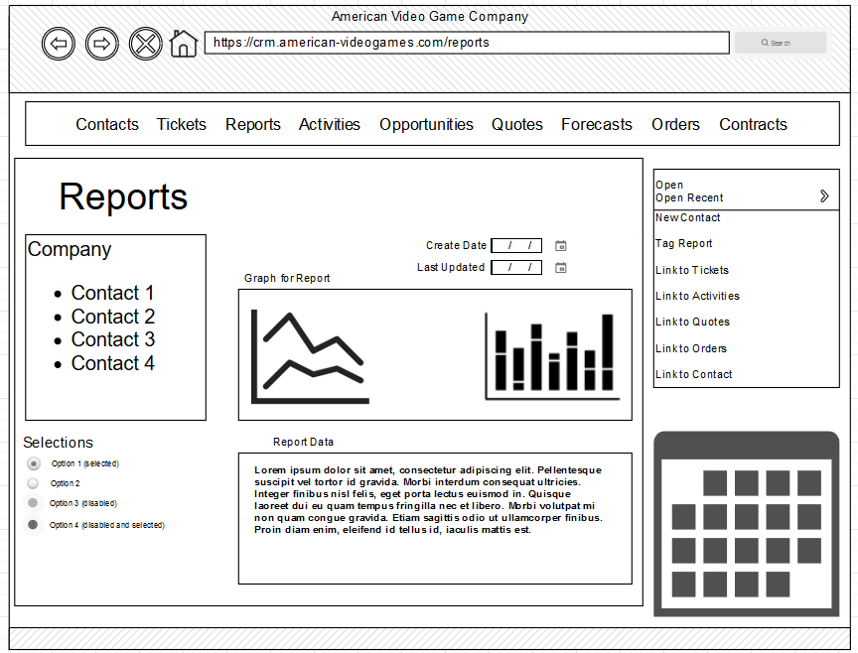

For activity management of visits and meetings the Sales team has the following requirements:

The CRM will act as a central repository for all visits with stakeholders and records of all meetings. It will track emails and act as a ticketing system with the ability to have meetings and visits tagged to specific employees.

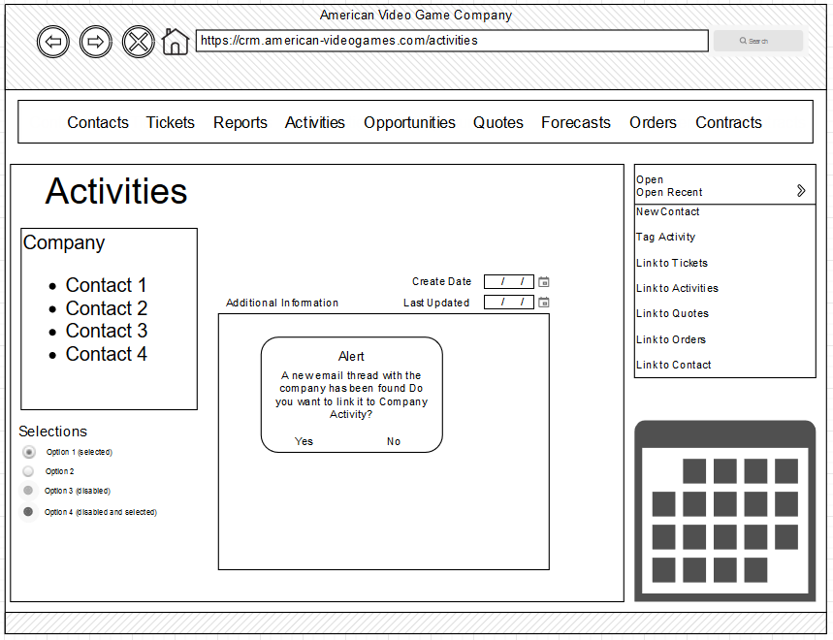

For opportunity management the Sales team has the following requirements:

The CRM must have the ability to track processes, manage pipelines, and ability to analyze the completion. It will implement workflow management for all sales related processes and create and track pipelines. The CRM will also allow users to perform various analyses like win/loss, competitive, competitive products, and discount approval analyses.

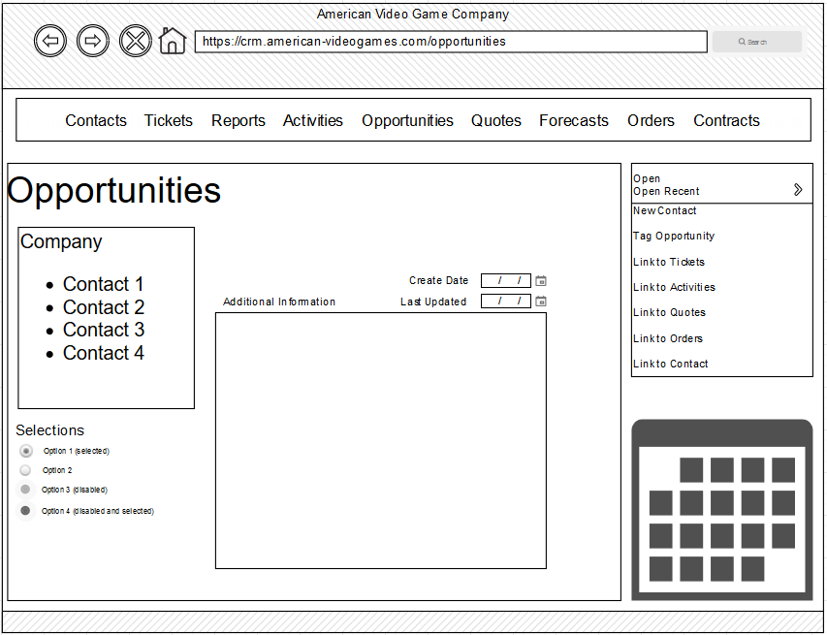

For quoting the Sales team has the following requirements:

The CRM will need to generate and assemble quotes, manage discounting taxes, calculate freight costs, track currency exchange, ensure electric signature for each document that requires one, configure prices and quotes, manage substitutions as needed, inventory management, shipping forecasts, contract pricing management, price catalog management and electronically deliver the quotes to the client.

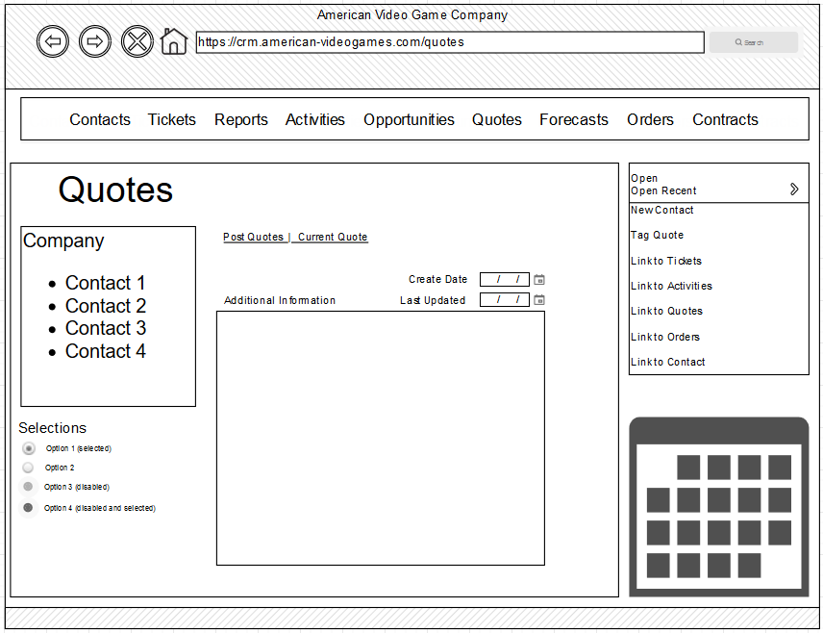

For forecasting the Sales team has the following requirements:

The CRM should help team members with the following abilities: manage domestic and foreign currency adjustments, allow for baselining, create and update manager adjustments, upsides, machine forecasting, display sales distributions, create and display forecast periods, and forecast products.

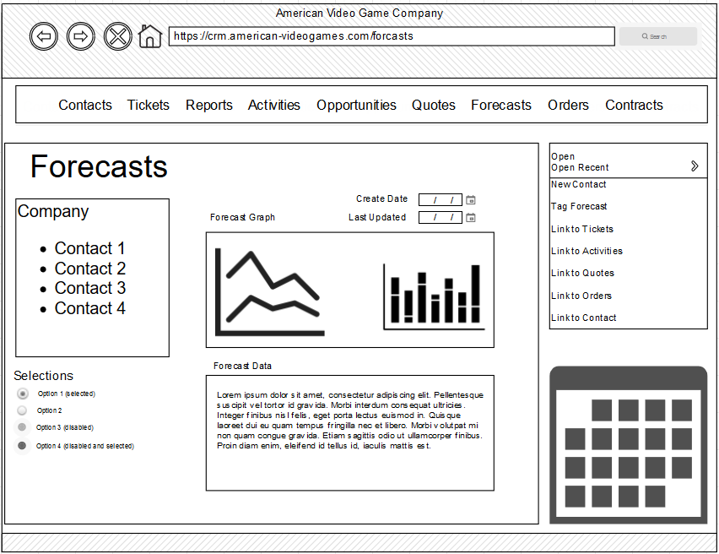

For order management the Sales team has the following requirements:

The CRM should allow quotes to be converted to orders, create and track orders, allow sales to create orders, and allow for product reorders.

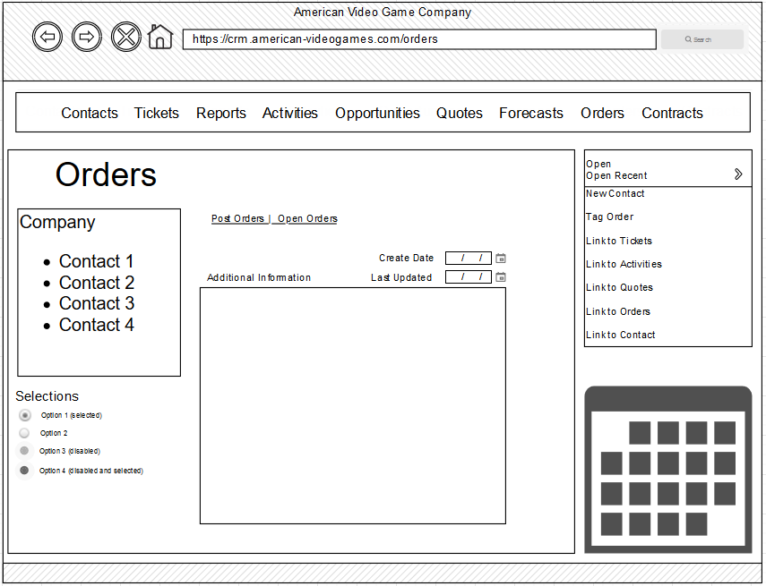

For contract management the Sales team has the following requirements:

The CRM will need to perform the following: track processor creation of contract, signing and approving contracts. The CRM will track terms, allow for approvals and authorizations of contracts. And manage contract terminations.

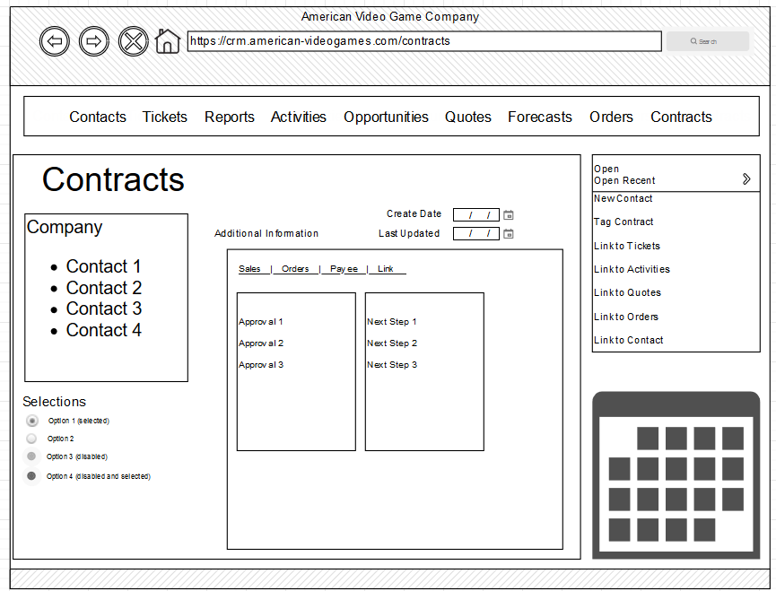

# Functional Requirements

The CRM will enforce role-based access control (RBAC) for all users. The system will accurately control data access, workflows, and editorial control based on the roles assigned to the end user. The permissions will only be granted by the administrator. We can use the existing active directory server for authentication and authorization of all employees.

Administrators will have the ability to manage permissions by creating roles or granting individual permissions to users for particular action needs. For this we can again use the active directory server to reduce resource and time cost for this management task.

In addition to RBAC and permissions management, the system will perform the following:

* Write-once, record activities by username and versioning will be implemented (e.g. archiving data without deleting the older records) this allows for auditing and maintains history, workflow management, and graceful rollbacks when needed. This can be implemented on the database by invoking audit logs and appropriately designing the database schema
* “Soft deletes” will be implemented for most users and “hard deletes” will be restricted to users with the proper roles and permissions. This will be invoked in the orchestrator by following appropriate permissions to update the relevant database records
* CRM will be testable and scalable with a clear support and maintenance structure. This will be ensured by the correct architecture for scale and will use our standard operating procedures for software launches
* CRM will have a clear roadmap for updates, upgrades, and feature enhancements/developments. This design doc is the first step in the roadmap direction
* CRM will have a clear licensing model with defined ownership rights. Since we are building our own software this will be easy to define and implement
* CRM data will be stored in the US and data processing, analyzing, and sharing will only be within the US unless otherwise approved. The software and databases will be in our offices which are in the US w already meet this requirement, but should we expand internationally we will pay special attention to address this to continually meet this requirement.
* Permissions and approval workflows will be well defined. The first step in this is met with the design doc

Workflow specific requirements include the following:

**Contract Management**

Form will dedupe existing company names and contracts, and it is recommended to merge similar sounding names with existing records and can be categorized by type or tagged. This process will keep the data ‘clean’ and in logical hierarchies allowing for sales to easily find contracts and users to easily self-serve. A business can have more than a single contract, office, or subcompany. Each contract will have more that a single role or permission assigned to them for many reasons including: job title, company, office location, or subcompany and they can move or change at any time.

A contract may not remain assigned to a single company and can be assigned to multiple companies, offices or roles as needed. Each field in the form will have a recommended type and format and will be verified against this recommendation when creating or editing business contacts. Partial entries, even though allowed, will be flagged for review so the entries will be as complete appropriately possible.

During sales, follow up, order, etc. calls users may tag enquiries to a business, contract entry, or create a new contact or business and tag it to an existing call entry activity.

**Ticketing**

The ticketing system will record contact information allowing the sales team to enter and track every communication or inquiry on a per contact basis. The ticket will include form fields for the name of the person calling, reason for the call, date and time stamps, follow-up, and additional relevant information field. Each ticket should have a unique ticket number. The CRM should pickup email replies and track them on a per contact basis. The CRM database should support all information required for this workflow to happen. An audit trail of all workflows and database changes must be implemented and maintained.

**Reporting**

The CRM system will deliver predefined reports and user defined reports for all data held in the databases. The user interface will be easy to use and allow for filtering, formatting, querying, and exporting of data. The reporting will allow for detailed reports and broad so granular reports. The CRM will allow the creation of dashboards, historical reports, and templates for executive level summaries. Users will click through the UI, save the report, or save and reuse any applied filters for future reports.

**Visits and Meetings Activity Management**

The CRM will act as a central repository for all records of meetings and visits with stakeholders. The system will allow for one- or two-way communication between MS Exchange/Outlook and itself. The system will include ticketing functionality as described in the ticketing requirements and shall export and re-import data for transfer to other internal systems efficiently. The CRM minimize risk and include appropriate validation processes. Visits and meetings will be able to be tagged to specific employees as needed.

**Opportunity Management**

The CRM will give the sales teams the ability to track, process, manage pipelines and analyze competition. It will implement workflow processes for all processes related to sales and it will create and track pipelines. The CRM will allow sales team members to perform various competitive analyses such as win/loss, competitive product, and discount approval analyses.

**Quoting**

The CRM system will generate and assemble quotes, manage discounts, apply proper taxing, calculate freight costs, calculate currency exchange, ensure electronic signature as needed, configure price and price quotes, substitution management as needed, inventory management, shipping forecasting, contract price management, catalog price management and electronically deliver the quotes to the client.

**Forecasting**

The CRM will help sales managers understand revenue expectations and predict profitability by managing domestic and foreign currency adjustments, allow for baselining, create and update manager adjustments, machine forecasting, upsides, display sales distributions, display and create forecast periods, and forecast products.

**Order Management**

The CRM will create orders, allow sales to take orders, convert quotes re-orders, allow for re-orders, and track orders all in a self-service portal.

**Contract Management**

With every deal needing a contract, contract management will be critical for the sales team. The CRM will track the process of creating, signing and approval of the contract. The CRM will also track terms, allow for approvals and authorization of contracts, and manage terminated contracts.

# NonFunctional Requirements

The proposed CRM will maintain the same or better performance as the current tool in use and have an intuitive generally easy to use interface. It will be easily scalable, modifiable, and easily integrate with other tools and services in the future without the need to rely on a single company or team to perform these actions. The CRM will be secure, and it will be balanced with usability. The CRM will have a clear licensing model with define ownership rights. The CRM will be compliant with all relevant laws and regulations and utilize industry best practices. The CRM will integrate with the company’s existing user active directory server for access rights and permissions.

# SOFTWARE DEVELOPMENT METHODOLOGY

The software waterfall method has been selected by the company for this project. The waterfall method clearly defines the path of the software development by the following steps: requirement analysis, system design, implementation, testing, deployment, and maintenance. For well defined predictable projects with teams that have experience working on similar applications the waterfall methodology if a good fit. Unlike Agile processes, the waterfall methodology as well-defined milestones. The waterfalls clear deadlines are appreciated by the company and can digest the different stages of development with little additional training on the development process itself. If using something like an Agile process could potentially be disruptive to the business if only because it is outside the norm for the business.

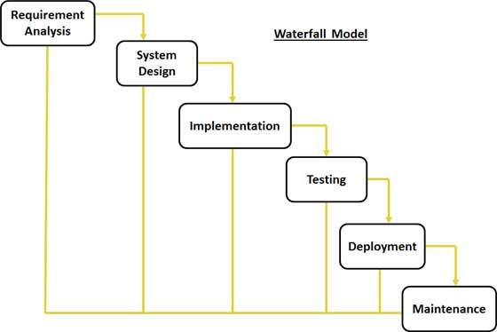

[This Photo](https://kenscourses.com/tc1019fall2016/syndicated/waterfall-method-7/) by Unknown Author is licensed under [CC BY-SA](https://creativecommons.org/licenses/by-sa/3.0/)

# Advantages of the waterfall method

With the clear structure of the waterfall methodology for delivery it allows us to work towards a predictable deployment and launch deadline. With the architecture and features defined in advance the waterfall provides a clear path through the development cycle.

When compared to Agile with the flexibility of not following a plan, freedom to define new processes and the expectations of customer collaboration would be to radical for the company.

# disAdvantages of the waterfall method

One of the main disadvantages to the waterfall method generally fall into the inability to react to risks or unknowns that surface later in the development cycle. Specifically, we are most concern that the sale team will decide either late in the development or early in the verification, that instead of following the established business processes and workflows, that they will decide to try out new workflows or features to the tool. The rigid development and time-based process gained with the waterfall methodology does not offer the ability to change requirements late in the development cycle.

If we end up in the situation where the sales team changes the workflows or changes to feature, then the Agile methodology would be best suited because the emphasis is on customer collaboration and the people over the process. The Agile process allows for surprises to be dealt with individually crafted methodologies crafted for each risk or process change.

# best SUITED

With the sales team expressing that they want to follow the current workflows in their existing CRM with a faster solution, we chose the Waterfall methodology over the Agile development process. We have worked on similar applications in the past and have an experienced team with this. We are not expecting the requirements to change much, and enough time do sequentially do everything. If we can run some tasks in parallel, we might even be able to shorten the deadline. With the Waterfall methodology we have a high chance of success following a clear structure and milestones.

# Design

With sales up 42% for the past 2 years, the sales team at American Video Game Company needs a new CRM to keep up with growth and allow for future growth since they are out growing their current CRM solution. The new should provide the company a tools to manage reporting, activity management, track sales and manage client contacts and contracts.

# Flowchart

The workflow illustrated below reflects the process flow when a salesperson creates a new contact and outlines the potential next steps that can be performed. Additional workflows can be created as needed.

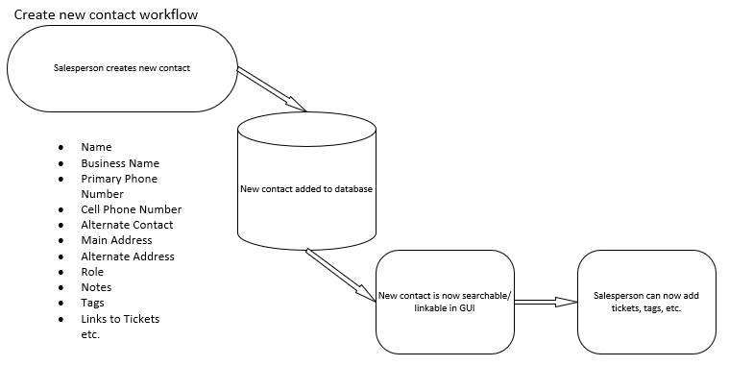

Figure 1: Sample Flowchart

# UML Diagram

This is the UML ERD diagram of the customer database that includes customer names, employees, tickets and logs.

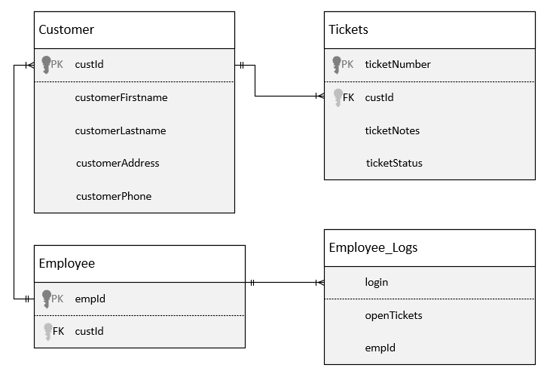

Figure 2: Sample Database

# GUI (Change title to fit needs)

Below is a sample mockup of the CRM Login screen that will be presented to end users when access the website.

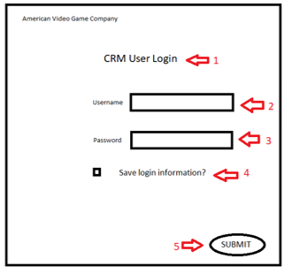

Figure 3: Sample GUI Mock-up

|  |  |  |  |
| --- | --- | --- | --- |
| GUI Control Mapping | | | |
| ID | Control | Property | Data Source |
| 1 | Textbox | On application open text = “CRM User Login” or null | N/A |
| 2 | Textbox | Button text = “” , user enters Username | Internal Variable |
| 3 | Textbox | Button text = “”, user enters Password | Internal Variable |
| 4 | Checkbox | Select to save login information | N/A |
| 5 | Button | OnClick to start login process of user into the CRM with Username and Password credentials entered. | N/A |

# Testing

To properly test the CRM solution, we will ensure all testing is against the necessary requirements and ensure integrity. We will choose 3 aspects of the CRM to test. Below are the 3 requirements to be tested.

* Ticketing System
* Hard Delete
* User Activity Logging

# User Interfacce testing

The purpose of the user interface test is to validate the user experience by testing the GUI aspect of the CRM. The test will check for consistency of expectations for items like button clicks, providing input, and the GUI representation of the CRM.

# Test Name 1

|  |
| --- |
| Requirement to be tested  User will create a ticket |
| Preconditions: Conditions that must be present before test case can successfully run  There must be a database with the correct schema for testing ticket creation process. There will need to be an implemented user interface to the ticketing system for proper testing. All aspects of the CRM will need to communicate with each other and this needs to be confirmed prior to the test. |
| Steps: The steps the tester must execute to test the feature.   1. Gather necessary customer information to be input 2. Populate customer data into appropriate fields 3. Click button to save ticket to the CRM system 4. Confirm successful ticket creation by searching for it 5. Tag relevant employees to the ticket 6. Confirm successful completion with message “Ticket successfully created” |
| Expected results:  The ticket would have the same look and feel in the GUI as a real ticket from the ticketing system and the expected results would be a successful creation of a ticket in the CRM system. |
| Pass/Fail:  Pass |

# Hard Delete Test

|  |
| --- |
| Requirement to be tested  Successful Hard Delete of customer contact information |
| Preconditions: Conditions that must be present before test case can successfully run  Requirements for this test are a database with the correct schema and a user with the correct role and permissions needed to perform a Hard Delete in the application. A contact management GUI will need to be in place for the user to access and perform the contact deletion. |
| Steps: The steps the tester must execute to test the feature.   1. Open Contact Management GUI 2. Search for the contact from the previous test 3. Open the contact details from the search return results 4. Click button to delete the contact 5. User must enter proper credentials when prompted for authorization to delete contact 6. Confirm deletion completed with message “Contact Successfully Deleted” 7. Search for the deleted contact and verify no search results are returned |
| Expected results:  After searching for the deleted contact, the expected results are a message reporting that zero contacts found. The logs will reflect the contact deletion, user performing the action and a date/timestamp. |
| Pass/Fail:  Pass. |

# User activity logging

|  |
| --- |
| Requirement to be tested  To properly support the business, all activities by employees and self-serve end users must be logged in a manner that can be retrieved and reviewed by management. |
| Preconditions: Conditions that must be present before test case can successfully run  A logging repository for user activity logs will need to be in place and the software solution must be accessible to authorized individuals. All aspects of the CRM will need to be able to store activity logs in the repository. |
| Steps: The steps the tester must execute to test the feature.   1. Sign into the CRM with an authorized username and password 2. Navigate to where an end user can enter data 3. Navigate to where an end user can update data 4. Navigate to where an end user can delete data 5. Sign out of the CRM system |
| Expected results:  The expected result of the test are that the logs repository reflects the successful addition, update and deletion of the data along with the user name, date/time stamp and action performed. |
| Pass/Fail:  Pass. |